JavaScript Introduction

JavaScript was invented by Brendan Eich in 1995, and became an ECMA (European Computer Manufacturers Association

) standard in 1997.

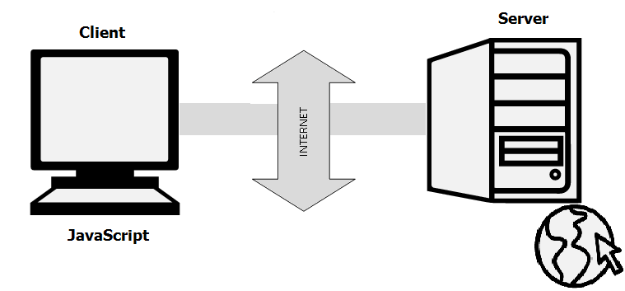

Client side scripting language

--Javascript, vbscript

Server

JSP,ASP

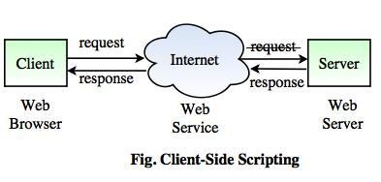

JavaScript and [Java](https://www.w3schools.com/java/default.asp) are completely different languages, both in concept and design.

ECMAScript is the official name of the language.

ECMAScript versions have been abbreviated to ES1, ES2, ES3, ES5, and ES6.

Since 2016 new versions are named by year (ECMAScript 2016 / 2017 / 2018).

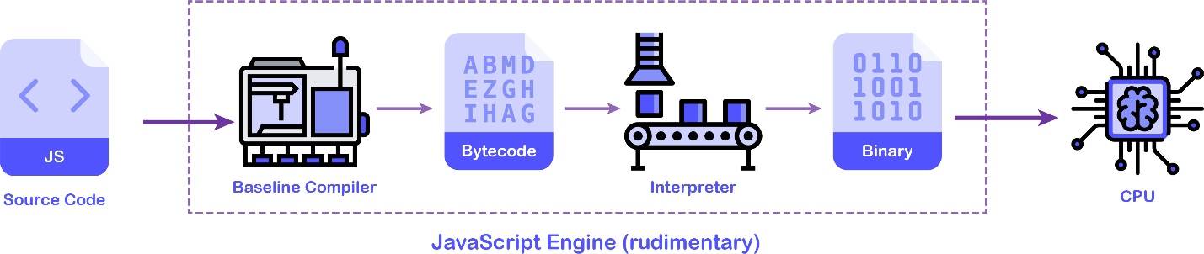

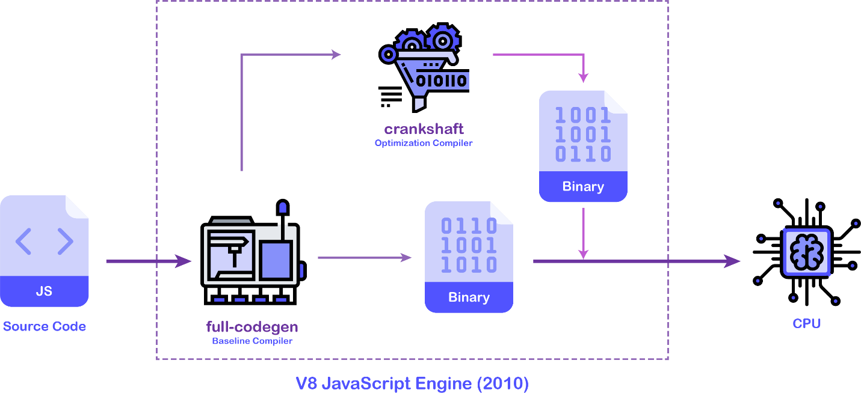

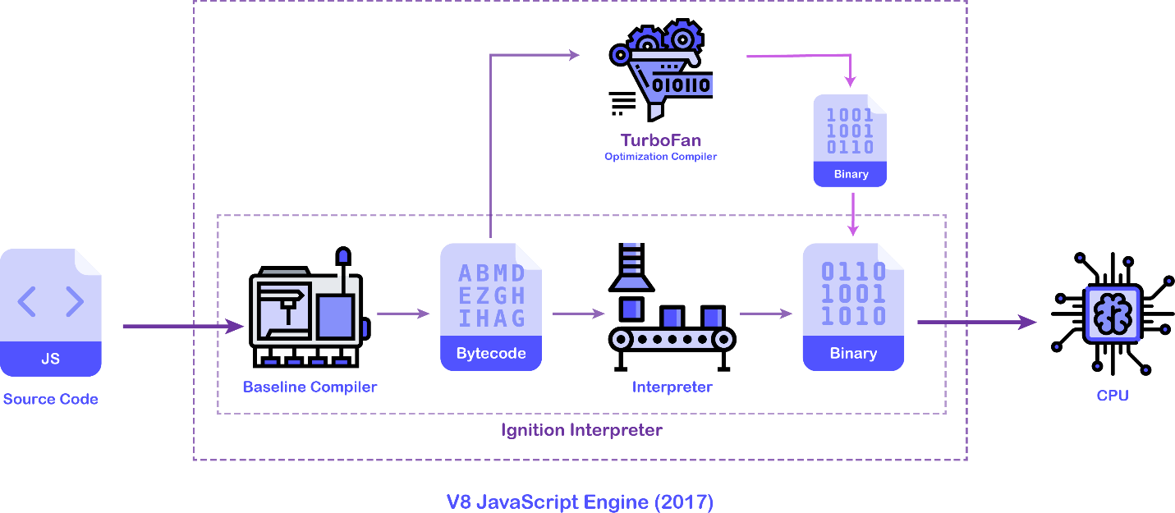

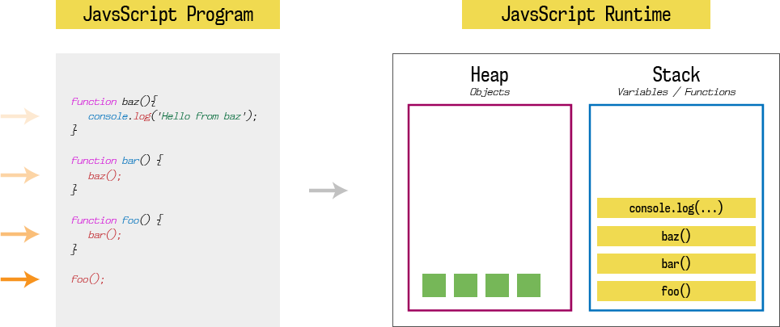

[Getting Started With JavaScript](https://www.programiz.com/javascript/get-started)

<!DOCTYPE html>  
<html>

<head>  
<script>  
function myFunction() {  
  document.getElementById("demo").innerHTML = "Paragraph changed.";  
}  
</script>  
</head>  
<body>

<h1>A Web Page</h1>  
<p id="demo">A Paragraph</p>  
<button type="button" onclick="myFunction()">Try it</button>

</body>  
</html>

External file: myScript.js

function myFunction() {  
  document.getElementById("demo").innerHTML = "Paragraph changed.";  
}

External scripts are practical when the same code is used in many different web pages.

JavaScript files have the file extension **.js**.

To use an external script, put the name of the script file in the src (source) attribute of a <script> tag:

Example

<script src="myScript.js"></script>

JavaScript can "display" data in different ways:

* Writing into an HTML element, using innerHTML.
* Writing into the HTML output using document.write().
  + The document.write() method should only be used for testing.
* Writing into an alert box, using window.alert().
* Writing into the browser console, using console.log().

<!DOCTYPE html>  
<html>  
<body>  
  
<h1>My First Web Page</h1>  
<p>My First Paragraph</p>  
  
<p id="demo"></p>  
  
<script>  
document.getElementById("demo").innerHTML = 5 + 6;  
</script>  
  
</body>  
</html>

<!DOCTYPE html>  
<html>  
<body>  
  
<h1>A Web Page</h1>  
<p id="demo">A Paragraph</p>  
<button type="button" onclick="myFunction()">Try it</button>  
  
<script>  
function myFunction() {  
  document.getElementById("demo").innerHTML = "Paragraph changed.";  
}  
</script>  
  
</body>  
</html>

<!DOCTYPE html>  
<html>  
<body>  
  
<h1>My First Web Page</h1>  
<p>My first paragraph.</p>  
  
<script>  
window.alert(5 + 6);  
</script>  
  
</body>  
</html>

You can skip the window keyword

<!DOCTYPE html>  
<html>  
<body>  
  
<script>  
console.log(5 + 6);  
</script>  
  
</body>  
</html>

<!DOCTYPE html>  
<html>  
<body>  
  
<button onclick="window.print()">Print this page</button>  
  
</body>  
</html>

Fixed values are called **Literals**.

Variable values are called **Variables**.

var A=5;

typeof(A)

* [JS Variables and Constants](https://www.programiz.com/javascript/variables-constants)

|  |  |
| --- | --- |
| var | let |
| var is used in the older versions of JavaScript | let is the new way of declaring variables starting **ES6 (ES2015)**. |
| var is function scoped (will be discussed in later tutorials). | let is block scoped (will be discussed in later tutorials). |
| For example, var x; | For example, let y; |

## JavaScript Constants

The const keyword was also introduced in the **ES6(ES2015)** version to create constants. For example,

const x = 5;

Once a constant is initialized, we cannot change its value.

const x = 5;

x = 10; // Error! constant cannot be changed.

console.log(x)

* [JS console.log()](https://www.programiz.com/javascript/console)
* [JavaScript Data Types](https://www.programiz.com/javascript/data-types)
* [JavaScript Operators](https://www.programiz.com/javascript/operators)
* Expressions

S=S*B+C

* [JavaScript Comments](https://www.programiz.com/javascript/comments)
* [JavaScript Type Conversions](https://www.programiz.com/javascript/type-conversion)